PLAN OF THE WEEK FOR CHAFFEY HIGH NAVY JROTC
MONDAY, APRIL 28 through SUNDAY MAY 4, 2025 (and Beyond)
Good Morning, Chaffey and Vina Danks Parents, Families, Friends, Colleagues, and Cadets.
Thank you to all the parents and cadets which attended the annual award ceremony on Friday, 25 April. It was a special time to honor parents, and cadets and time-honored ceremony titled “Relieving the Watch”. Thank you, cadets, for such an amazing execution of this ceremony. I was deeply moved it was difficult for me to hold back tears.

This week will be our final week for CAASPP Testing. The schedule is provided below:
Mondays and Tuesdays - Periods 1, 2 and 3 will meet: (Periods 4, 5 and 6 will not be meeting)
Wednesdays and Thursdays – Periods 4, 5, and 6 will meet: (Periods 1, 2, and 3 will not meet)
Fridays will be normal Friday class meetings, with all periods meeting. Below is a calendar schedule showing this:
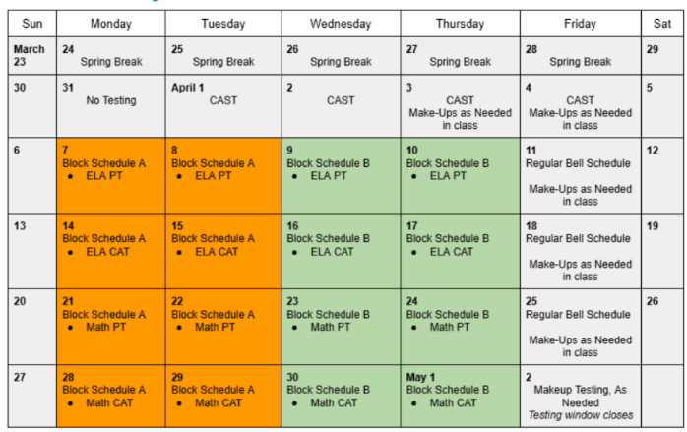 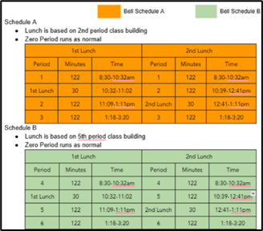
Next week’s schedule is as follows:
APR 28 to MAY 4, 2025
MON, APR 28 – (Per 1, 2, 3 Only) - PE Day And Drill!
TUE, APR 29 – (Per 1, 2, 3 Only) – Academics (CAASPP Testing 11th Graders)
WED, APR 30 – (Per 4, 5, 6 Only) –
– CDR GARCIA (Aea Manager) visits Chaffey to view spaces - Command Staff Brief
THU, MAY 1 – (Per 4, 5, 6 Only) – Academics (CAASPP Testing 11th Graders)
FRI, MAY 2 – PE Day
– Color Guard for College Signing Night
SAT, MAY 3 – Bloomington Color Guard Competition
SUN, MAY 4 - No Events Scheduled
-------------------------------------------------------------------------------------------------------------
FUTURE EVENTS
Wed, 7 May – Esperanza Community Service and Color Guard GWS
Sun, May 11 to Wed May 14 – Elks Club “Run for the Wall” Community Support
Mon, 12 May – Ontario Orchestra Program Support
Tue, 13 May Chaffey District Award Ceremony CG 4:45 PM Hill Auditorium
Thu, 22 May – Graduation – Color Guard, Escorts as needed
Mon, May 26 – Memorial Day Ceremony Bellevue Cemetery 8:00-11:00 am
Thu, May 29 – CG for San Bernardino County Schools Graduation GWS (5:30 pm)
Area 21 NJROTC Sailing Academy ($275 per cadet) - Only ONE Cadet per session this year. Session ONE: 19 to 21 June; Session TWO: 23 to 25 June
Area 21 NJROTC Leadership Academy: Dates to Be Announced
Fri – July 4 - Ontario Independence Parade
LCDR Jones Master Chief Razo
(909) 921-7274 (619) 292-9323

